

Assessment Cover Page
Student Full Name Valeria Cantu Angel
Student Number
2026679
Module Title
Strategic Thinking
Assessment Title
CA-1 Strategic Thinking
Lecturer/Supervisor
Taufique Ahmed
Assessment Due Date
25/10/2026
Date of Submission 25/10/26

Use of AI Tools

I acknowledge the use of ChatGPT (Open AI) for the purpose of [brainstorming ideas, organising the structure of the project, improving grammar and clarity, and for understanding the assessment requirements.
I have not used any AI tools or technologies in the preparation of this assessment.
Declaration
By submitting this assessment, I confirm that I have read the CCT policy on academic misconduct and understand the implications of submitting work that is not my own or does not appropriately reference material taken from a third party or other source.
I declare it to be my own work and that all material from third parties has been appropriately referenced.
I further confirm that this work has not previously been submitted for assessment by myself or someone else in CCT College Dublin or any other higher education institution.

Table of Contents
Table of Contents 3
1. Introduction. 1
2. 1
Business Problem Definition. 1
3. 2
Aim and Objectives. 2
4. Project Scope. 2
5. Proposed Methodology. 2
6. Data Sources and Permissions. 4
7. Ethical, Legal and Data-Protection Considerations. 4
8. Expected Deliverables. 4
9. Proposed Timeline. 5
10. References. 6
11. Appendix. 7

1. Introduction.
This research considers the one year survival rates of newly established businesses across selected sectors in Ireland. The objective is to identify differences in survival rates between various sectors and cohorts of business creation, as well as to determine whether it is possible to estimate such rates for future projections based on current data.

This information may prove valuable to those looking to launch their own business and improve their business planning. The project will focus on examining general trends.
I have chosen this project because I’m interested in understanding why business survival rates vary by sector, and how data analysis can transform existing information into practical evidence for business planning.

2.

Business Problem Definition.
When planning the launch of a new enterprise or business, prospective entrepreneurs face challenges stemming from uncertainty regarding survival rates in specific sectors.
This raises the question: How can current data on survival at the sectoral level help shape expectations for a new business first year? We will analyse recent data on business creation and survival, and evaluate predictive estimates of first year survival rates for subsequent cohorts, using information from CSO. This project will leverage this data to compare actual patterns and assess estimates for future cohorts.
Its objective is to provide an evidence base at the sectoral level that entrepreneurs can consider alongside financial projections and market research without this constituting an individual prediction or a recommendation to enter any specific sector.

3.

Aim and Objectives.
The goal is to analyse data on business creation and survival in different industrial sectors and to assess how accurately we can estimate business survival rates during their first year for future cohorts. Through this project, we would provide the necessary and useful data to help future entrepreneurs understand the risks specific to their sectors when they are ready to start a new business.
Obtain and prepare historical data on business creation and survival rates during the first year in different sectors for subsequent analysis.
Develop forecasting models to estimate business survival rates during the first year.
Evaluate the models by comparing their estimates with actual data.
Use the final findings to help future entrepreneurs understand the risks involved in starting a new business.

Project Scope.
The primary focus will be on analysing historical data regarding the creation and survival of businesses, as well as developing methods to estimate future survival. The results of these estimates will be compared against actual survival data to assess their accuracy.
The finding will be presented through charts and a final analysis, intended to help future entrepreneurs understand survival risks across different sectors. This analysis is contingent upon the availability, quality, and sources of the data. It does not predict specific instances of failure or success, nor does it identify particular causes and it is not a substitute for financial analysis or market research for new ventures or businesses.

5. Proposed Methodology.

The project will involve a multi stage analysis process. First, all available information from the CSO will be reviewed to identify and classify data regarding one-year survival rates in an appropriate manner. This will include verifying records, defining specific categories, and distinguishing between the creation of a new business and the survival of an existing one.
The analysis will compare survival rates across different sectors and cohorts , using official data presented through graphical models, and will culminate in a final report. These findings will serve to support financial analysis and market research.
The information generated by this project will depend on the number of usable observations and the consistency of the available official data.

Figure 1 illustrates the proposed analytical workflow, from reviewing official CSO data to evaluating estimates and communicating the findings.
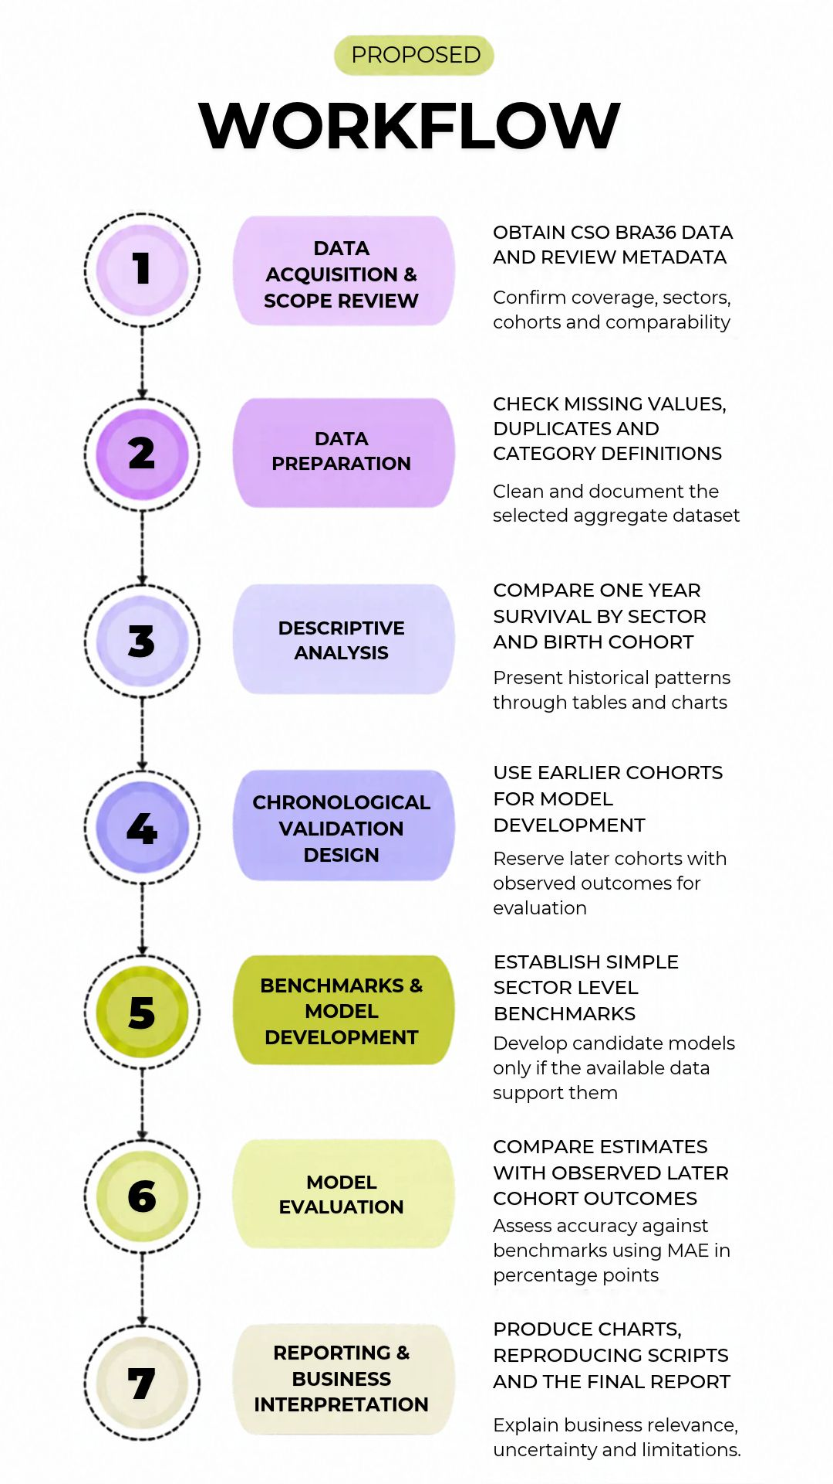
Figure 1. Proposed analytical workflow for one year enterprise survival analysis.

6. Data Sources and Permissions.
The primary data source proposed is the BRA36 business survival table, which is produced by the CSO, it provides information broken down by economic activity based in the NACE Rev. 2 classification and by enterprise size, measured by employment.
The downloaded files and their associated metadata will be reviewed before the final analytical dataset is defined. The project will cite the source CSO, specify the tables used, and document the dates on which the data were downloaded, as well as any modifications made to them.

7. Ethical, Legal and Data-Protection Considerations.
The analysis process will utilize pre existing statistics, no attempt will be made to gain access to corporate records that could lead tom the exposure of any identifiable or personal data. No new primary data will be collected, and no participants will be recruited for the study. Incomplete or inaccessible data will not be imputed, and no attempts will be made to determine the identify of specific companies.
The findings will be discussed in context, taking into account the degree of uncertainty, changes in methodology, and the limitations of an industry level analysis. Lower survival rates will not be considered proof that all corporations within an industry are destined to fail. The sources of the data and any transformations applied will be cited, and the study will adhere to ethical and artificial intelligence guidelines.

8. Expected Deliverables.
8.1 Analytical dataset with proper documentation for chosen sectors and cohorts.
8.2 Reproducible scripts for data preprocessing, descriptive analysis and model evaluation.
8.3 Comparison charts and tables with regard to one year survival rate among various sectors and cohorts.
8.4 Evaluation of prediction methods vis a vis the simple benchmarking methods.
8.5 Final report that details the insights gained, business implications, uncertainty and limitations.

9. Proposed Timeline.

The project is provisionally planned across two semesters. Semester 1 will focus on reviewing and preparing the data, conducting descriptive analysis and designing the validation process, and semester 2 will focus on developing and forecasting models, evaluating their performance and preparing the final report.
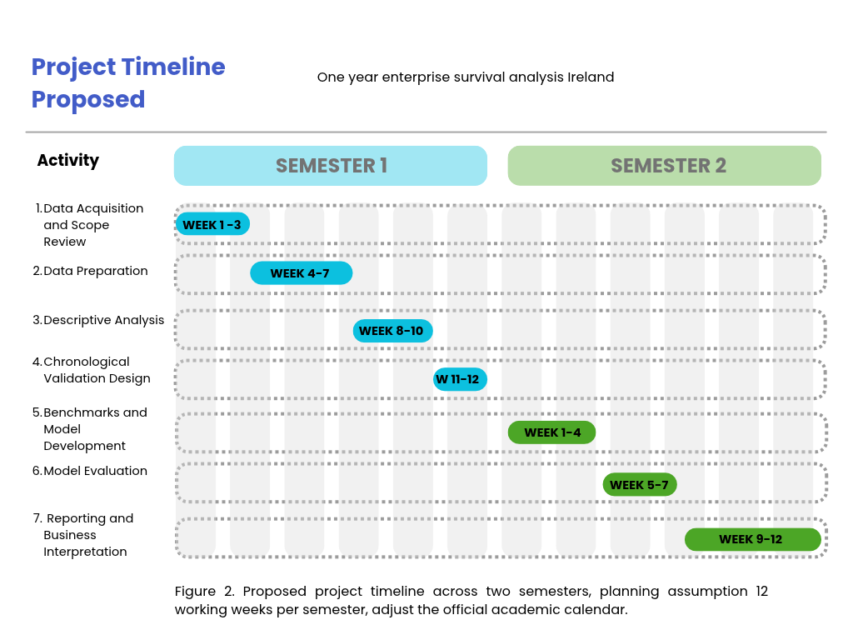

10. References.

Central Statistics Office (2024) BRA36 – Enterprise Survival NACE Rev 2
Available at: https://data.gov.ie/dataset/bra36-enterprise-survival-nace-rev-2 (Accessed: 19 October 2026)
Central Statistics Office (n.d.) Copyright Policy. Available at: https://www.cso.ie/en/aboutus/whoweare/copyrightpolicy/ (Accessed: 20 October)
Local Enterprise Office Dun Laoghaire – Rathdown (n.d.) Business Plan Guide. Available at: https://www.localenterprise.ie/dlr/start-or-grow-your-business/starting-your-own-business-guide/business-plan-guide/ (Accessed: 19 October)
Central Statistics Office (2025) Business in Ireland 2023 - Insights on the Lifecycle of Businesses: Background Notes. Available at: https://www.cso.ie/en/releasesandpublications/ep/p-biiilb/businessinireland2023-insightsonthelifecycleofbusinesses/backgroundnotes/ (Accessed 21 October 2026)

11. Appendix.

